Lou _ Tool Year 2 Week5 ,26 March 2018

Week 5 – Tools, Software and Systems: Year 2 Homework

HOMEWORK:

- Design your site (on paper or digital)

- Design all pages!

- Show each element:

- Annotate what type of html element it will be

- Annotate id and class

- Is it a link? Where to? / any interaction

- color/font/text?

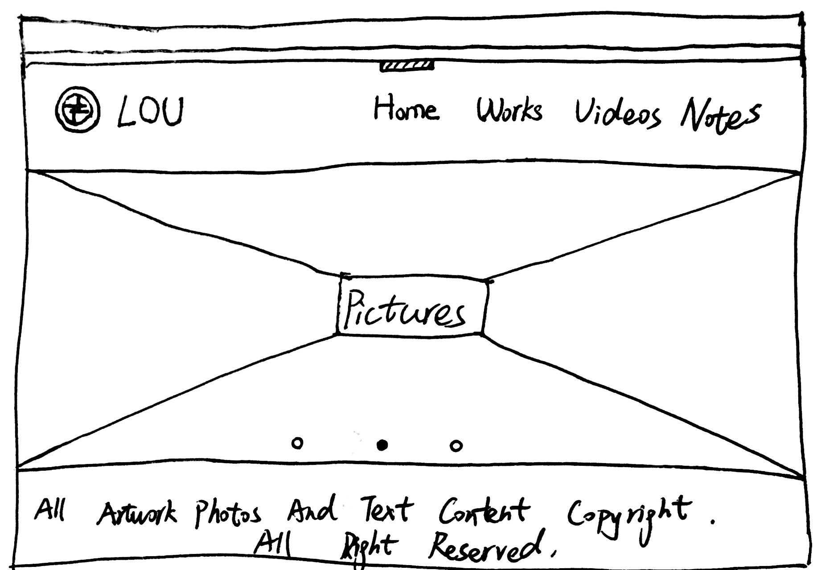

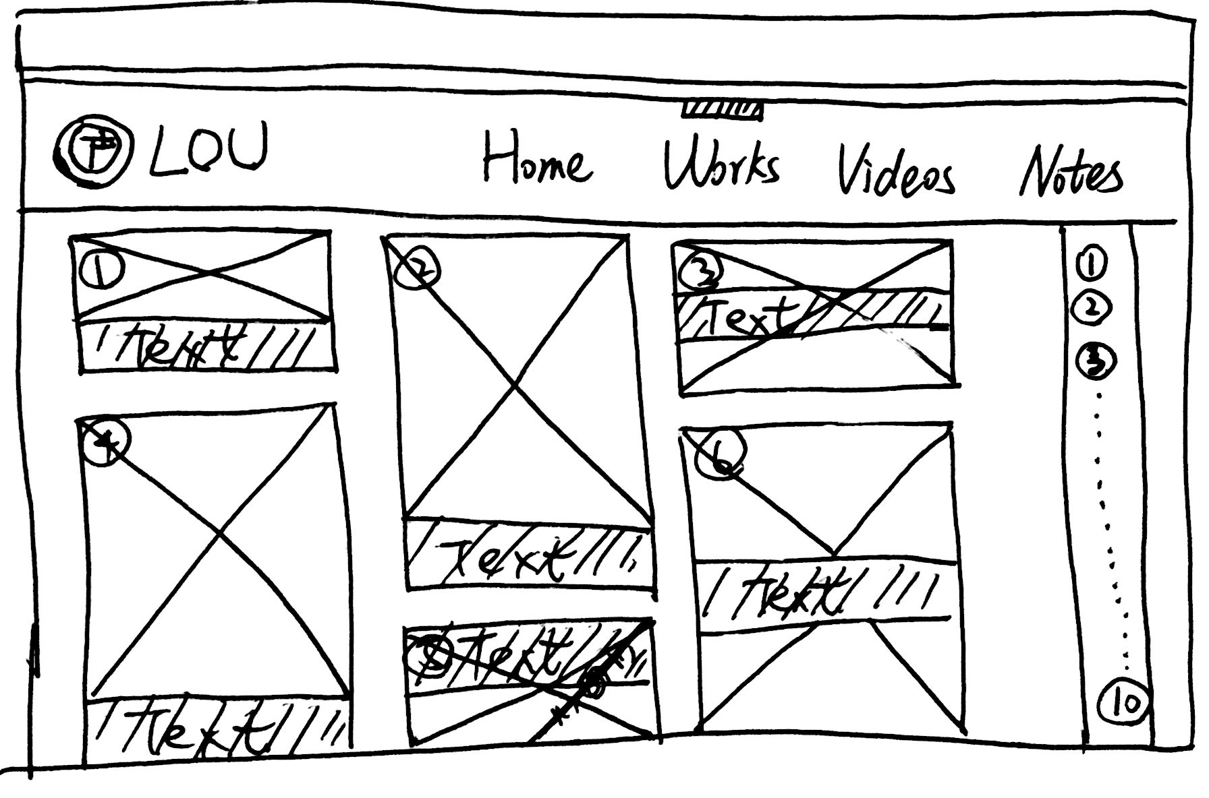

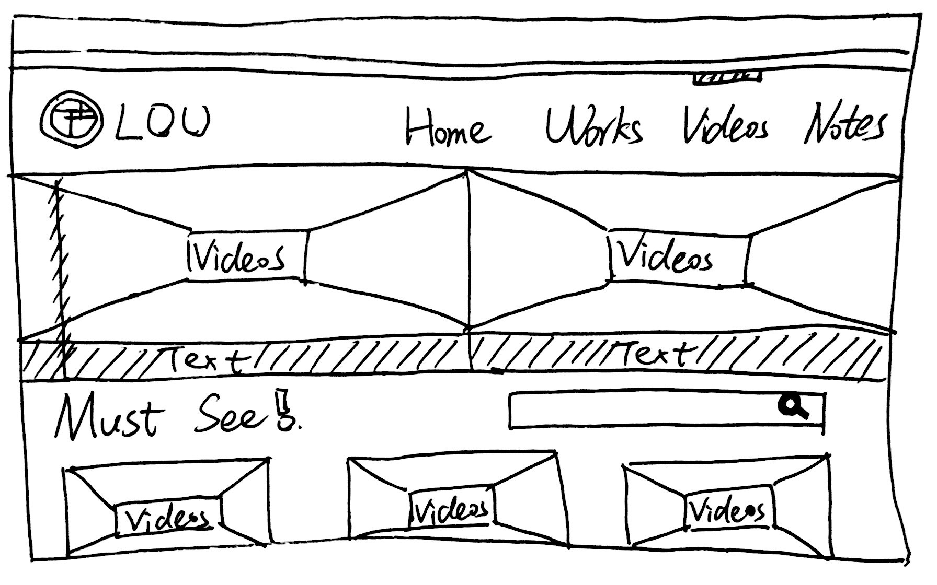

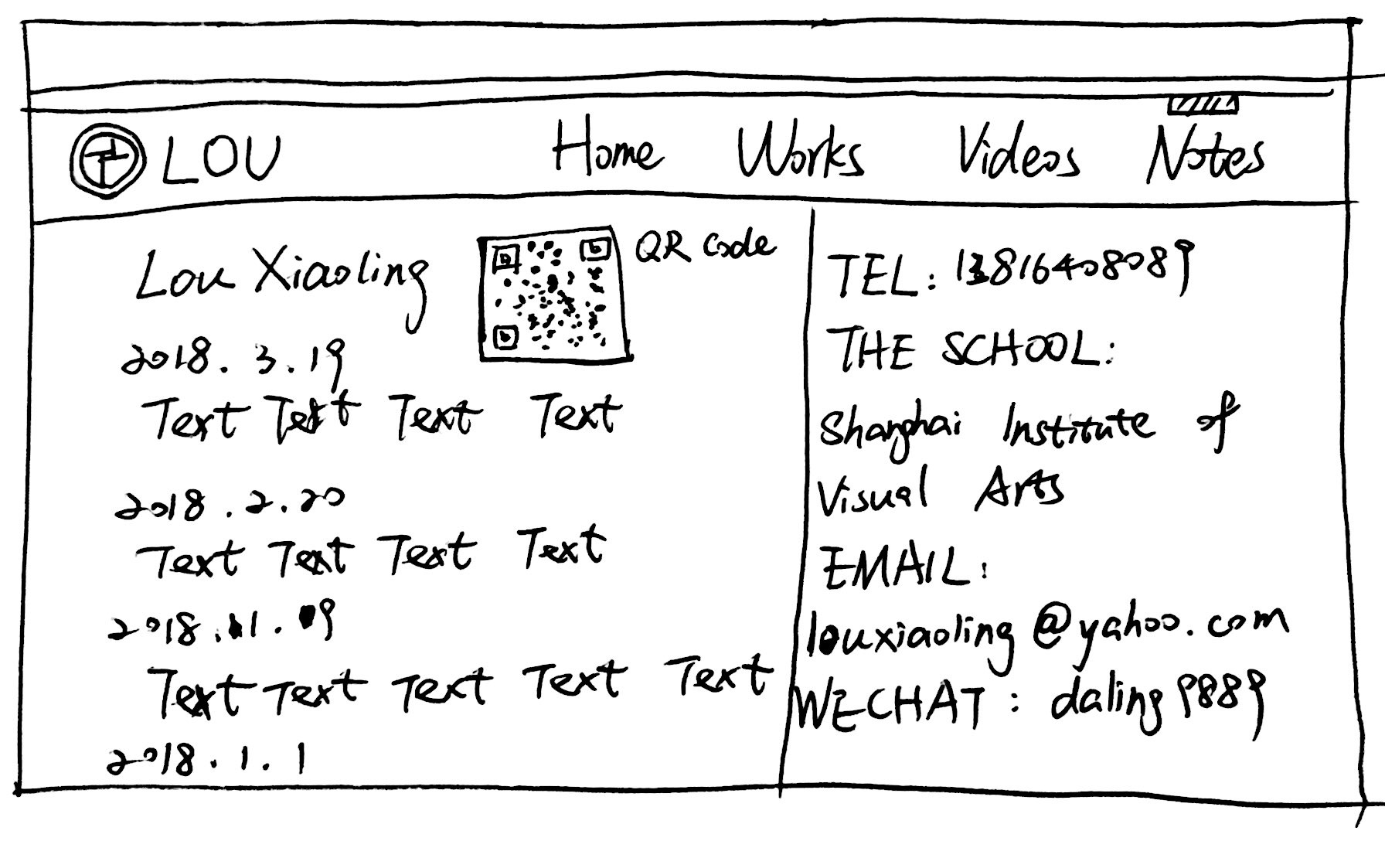

Document Structure:

<h1..h6>…</h1…h6>

<div>…</div>

<span>…</span>

<p>…</p>

<br/>

Text:

<strong>…</strong>

<b>…</b>

<em>…</em>

<i>…</i>

Images:

<img />

src=”url”

alt=”text”

height=””

width=””

align=””

border=””

vspace=””

<map></map>

<map name=””>…</map>

<area />

Video link:

<video> <iframe height=498 width=510 src='http://player.youku.com/embed/XMjA1OTYxNTM2NA==' frameborder=0 'allowfullscreen'></iframe>”</video>

<video> <iframe height=498 width=510 src='http://player.youku.com/embed/XMzQ5MzA3Nzk5Mg==' frameborder=0 'allowfullscreen'></iframe> </video>

color:

屏幕快照%202018-03-20%20上午1.03.20.png # a48763

屏幕快照%202018-03-20%20上午1.04.27.png # ffffff (background color)

屏幕快照%202018-03-20%20上午1.07.18.png #2f2f2f(font color)

font family: Arial Regular

font size:14px

letter spacing:0.2px

line height:18px